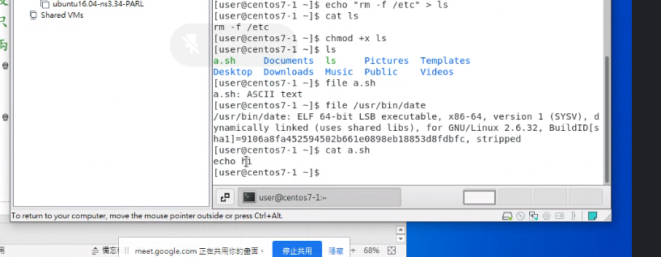

File a.sh

//to run the .sh file

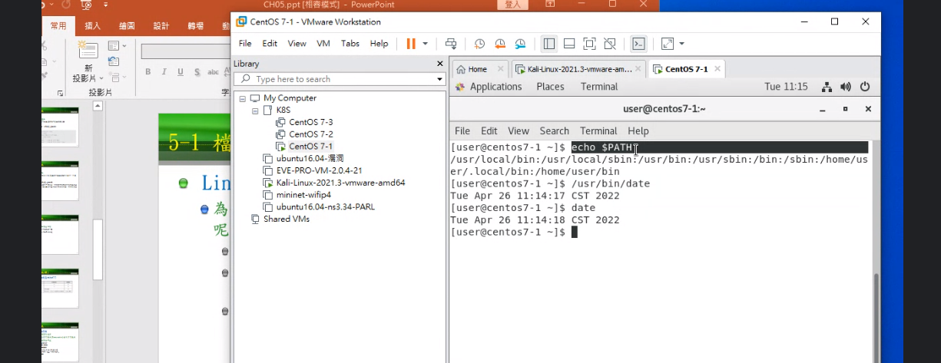

Echo $PATH

//to execute

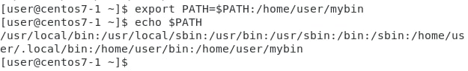

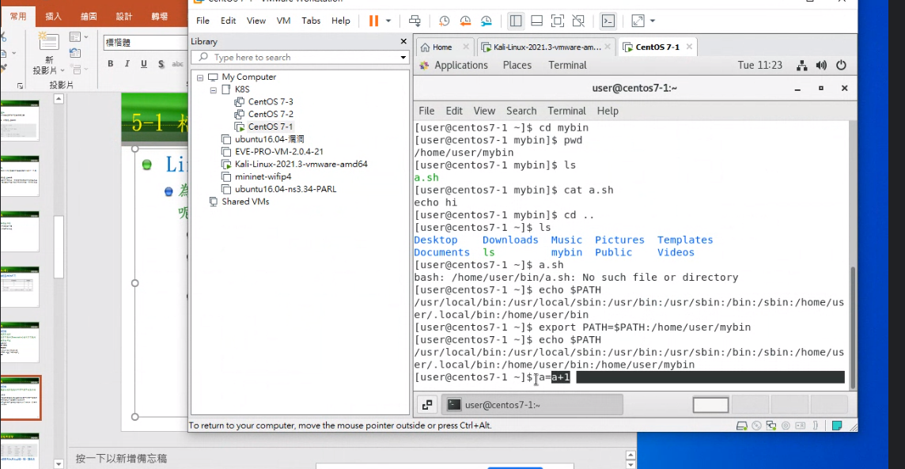

**Ssh tunnel**

SSH tunneling, or SSH port forwarding, is a method of transporting arbitrary data over an encrypted SSH connection. SSH tunnels allow connections made to a local port (that is, to a port on your own desktop) to be forwarded to a remote machine via a secure channel.

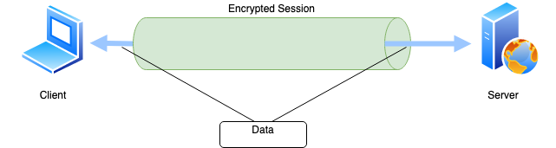

$ssh -L 5432:127.0.0.1:5432 user@<remote_db_server>

//use to build a connection between 10.0.0.1 and 10.0.0.2 using ssh tunnel

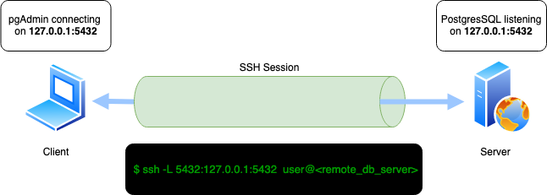

**Firewall command**

$systemctl stop firewalld

//use to deactivate the firewall

$systemctl enable firewalld

//to enable firewall

$systemctl start firewalld

//use to start firewall

$systemctl status firewalld

//use to check the status of firewall

**Make a simple website**

$ python3 -m http.server --bind 127.0.0.1 9000

//you are able to go to the website http://127.0.0.1:9000